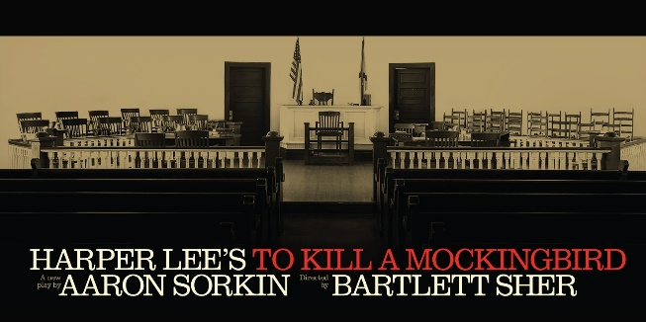
TO KILL A MOCKINGBIRD Lied Center Lincoln, NE, Wednesday 6/12/24 7:30 show time $150.00

PASSENGER INFORMATION
First Name:_______________________________________
Last Name:_______________________________________
Name Tag:________________________________________
Address:_________________________________________
City:_________________________ St:_______ Zip:______
Cell Phone:_______________________________________
Email:_____________________________________________
(please provide e-mail if available)
Emergency Contact:_____________________________
Emergency Contact Phone:_____________________
PASSENGER INFORMATION
First Name:______________________________________
Last Name:______________________________________
Name Tag:_______________________________________
Address:_________________________________________
City:________________________ St:_______ Zip:______
Cell Phone:______________________________________
Email:____________________________________________
(please provide e-mail if available)
Emergency Contact:____________________________
Emergency Contact Phone:____________________

Pick up Location: Pick up Location:
Kearney_____ Sams Club GI ________ I80 ________ Kearney _____ Sams Club GI ______ I80 _______

Full payment is required with your reservation form.
Mail Registration forms and payment to: Five Points Bank; Att: Linda Green
PO Box 1507, Grand Island NE 68803
OR: Debit my account #_____________________________________
Cancellation: NO charge if replacement is available (Name change)

Questions: please contact Linda Green 308-389-8783 linda.green@5pointsbank.com
Tracey Shada 308-234-6171 tracey.shada@5pointsbank.com
Internal use Only: Date Reservation taken _________________________________

