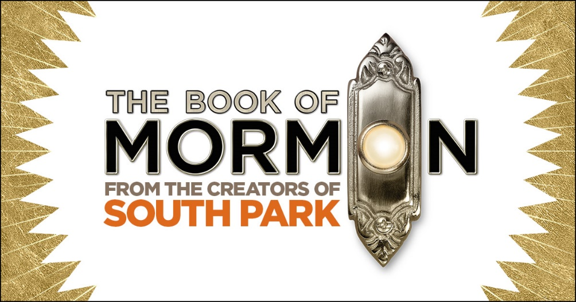
Saturday, March 25, 2023- Lied Center-Lincoln
Show time 2:00 p.m.
$165.00
The New York Times calls it “the best musical of this century.” The Washington Post says, “It is the kind of evening that restores your faith in musicals.” And Entertainment Weekly says, “Grade A: the funniest musical of all time.” Jimmy Fallon of The Tonight Show calls it "Genius. Brilliant. Phenomenal." It’s THE BOOK OF MORMON, the nine-time Tony Award® winning Best Musical.
This outrageous musical comedy follows the adventures of a mismatched pair of missionaries, sent halfway across the world to spread the Good Word. With standing room only productions in London, on Broadway, and across North America, THE BOOK OF MORMON has truly become an international sensation. Contains explicit language.
Departing from Kearney approximately 10:00 a.m.
Tour includes:
-Deluxe motor coach transportation from Kearney with
pick ups in Grand Island and I80/281
-Lunch before the show in the Haymarket
-Lower level ticket for the show
Full payment is due with reservation. Cancellation Policy: If we have a waitlist, full refund is available. If there is no wait list partial refund may be available. Ticket price is non-refundable
For reservations or more information, please call:
Linda Green at: 308-389-8783 linda.green@5pointsbank.com
or Tracey at: 308-234-6171 tracey.shada@5pointsbank.com

