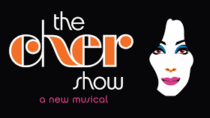
WEDNESDAY APRIL 3, 2024
7:30 P.M. SHOWTIME
ORCHESTRA LEVEL TICKETS
LIED CENTER – LINCOLN NE
$150.00
DINNER BEFORE THE SHOW
ROUND TRIP MOTOR COACH STARTING IN KEARNEY WITH PICK UPS AT SAMS CLUB AND 180/281

FOR RESERVATIONS OR MORE INFORMATION PLEASE CALL:
Linda Green at 308-389-8783, linda.green@5pointsbank.com
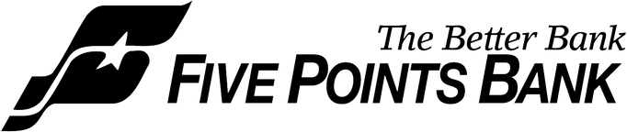
Tracey Shada at: 308-234-6171 tracey.shada@5pointbank.com

