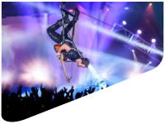

1.

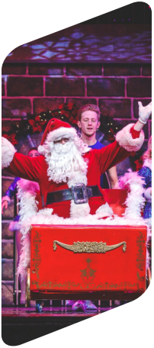
BRANSON HOLIDAY EXTRAVAGANZA
November 19-23, 2024
Get ready for neon lights, heartwarming Christmas celebrations, and astonishing Broadway-caliber shows! Amid the Christmas magic, step into the world of the Titanic, marvel at the talents of the Haygood family, and watch the miracle of Christmas come to life on stage. Branson’s Christmas Wonderland and an amazing light display will also get you in the holiday spirit!

Hold your spot now with
registration and a refundable deposit!

2.

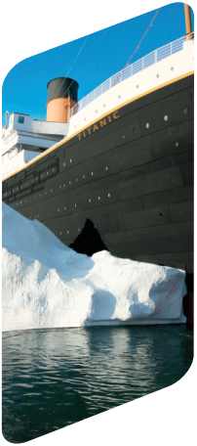

3.

4.
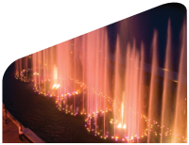

5.
1-5. Branson Convention and Visitors Bureau

DAY 1 TUESDAY, NOVEMBER 19 KANSAS CITY, MO (Dinner)
Today we will begin our journey south with stops for comfort and lunch on our own along the way. Upon arrival in Kansas City, MO, our first stop will be the Hallmark Visitor Center to discover how a teenager from Nebraska tucked two shoeboxes of postcards under his arms and set out to create an iconic company in Kansas City. Interactive displays and fascinating exhibits offer a glimpse into the rich history and creative spirit of Hallmark. The center is also home to an amazing collection of Christmas trees which were decorated each year for Hallmark founder J.C. Hall by his employees. After we have checked in to the Hampton Inn & Suites Kansas City Downtown Crossroads (or similar), we will gather for a festive welcome dinner.
DAY 2 WEDNESDAY, NOVEMBER 20 BRANSON, MO (Breakfast, Dinner)
After breakfast we will continue on to Branson and make our way to the Grand Village Shops to do some shopping at Kringles, Missouri’s largest year-round Christmas store! Time will also be available to explore the rest of the Grand Village Shops and grab lunch on our own. Browse the designer brands and trendy styles in the fashion boutiques; grab a novelty item or collectible in the gift stores; and discover handmade soaps, leather goods, tea, and art in the speciality shops. Then we are off to see Branson’s most popular Christmas show, The Haygoods Christmas Extravaganza. All our favorite Christmas songs are performed as only the Haygoods can – with light up instruments and costumes, pyrotechnics, stunning visual effects, intricately woven harmonies, and an energy that will keep us on the edge of our seats! We’ll cap off our day with dinner followed by the Lights of Joy Christmas Drive-Thru to marvel at the more than 300 traditional and whimsical displays featuring over one million twinkling Christmas lights. Our accommodations for the next three nights await at Spark by Hilton (or similar).
DAY 3 THURSDAY, NOVEMBER 21 BRANSON, MO (Breakfast, Lunch)
We’ll make the short drive to the College of the Ozarks this morning for a guided tour of their campus. Also known as “Hard Work U,” the students work at one of more than 100 campus jobs rather than paying tuition. Lunch will be served at the award-winning Keeter Center where the culinary students prepare delicious meals. We will then step into a festive fantasy at King’s Castle Theatre with one of Branson’s largest holiday productions, Branson’s Christmas Wonderland. The show rings in the spirit of the Christmas season with high-energy dance, elaborate costumes, beautiful scenery, gorgeous production numbers, and the highest-kicking chorus girls this side of the North Pole! This evening will be spent at the Branson Landing boardwalk to explore the holiday lights and decorations at our leisure, do some last-minute Christmas shopping, and have dinner on our own at one of the area’s countless restaurants. Be sure to catch Branson Landing's famous water and fire performance choreographed to Christmas music on the shores of Lake Taneycomo!
DAY 4 FRIDAY, NOVEMBER 22 BRANSON, MO (Breakfast, Lunch, Dinner)
Enjoy breakfast at the hotel before we head to the Titanic Museum, beautifully decorated for the holidays. The museum offers a peek into the world of the most famous luxury liner with galleries of artifacts from the ship and passengers and painstakingly re-created cabins and hallways. We’ll walk down the grand staircase, touch an iceberg, and try to stand on the sloping decks! Lunch will be enjoyed at a local restaurant before we head to the Sight & Sound Theatre for an amazing production of Miracle of Christmas, which brings to life the original Christmas story with massive sets and live animals. We’ll travel back in time to Bethlehem as we journey alongside Mary and Joseph, a flock of surprised shepherds, and three wise men. This interactive performance will captivate our senses with the smells of Christmas filling the air and the sounds of the live camels, horses, sheep, donkeys, and more! Our day will come to an end with a delicious farewell dinner to celebrate our time in Branson.
DAY 5 SATURDAY, NOVEMBER 23 HOME (Breakfast)
After breakfast we will depart for home with stops for comfort and lunch on our own along the way.

TERMS & CONDITONS
For full tour terms and conditions, please visit www.stardestinations.com/terms-five-points-branson
Branson Convention and Visitors Bureau

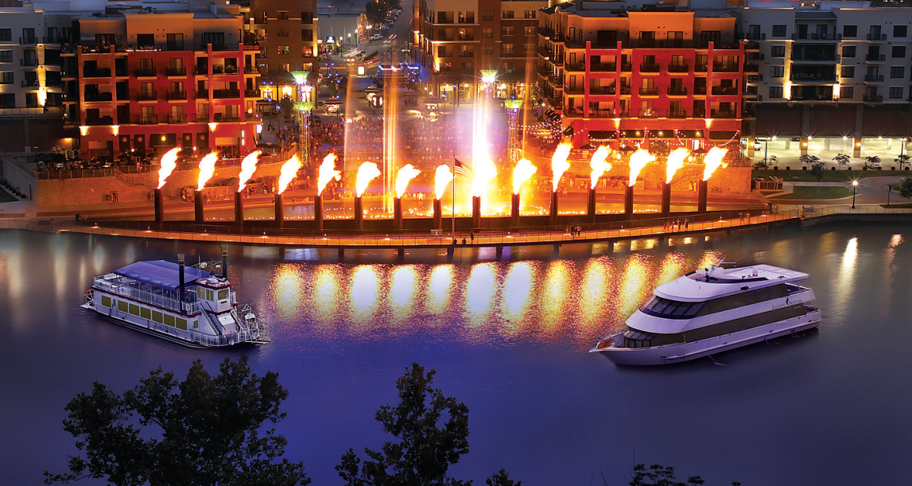
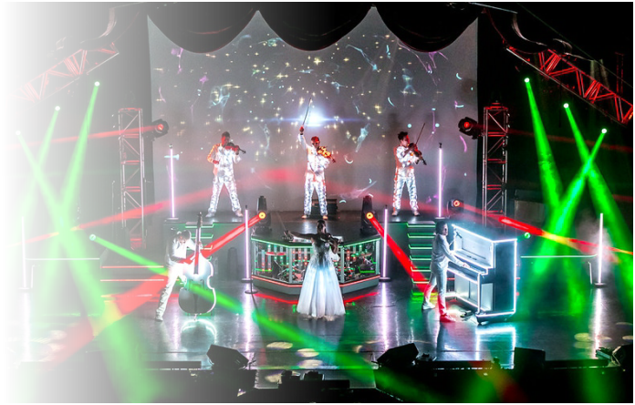

INCLUSIONS  Ÿ Private motorcoach transportation  Ÿ 4 nights’ accommodations  Ÿ 9 meals (4 breakfasts, 2 lunches, 3 dinners)  Ÿ Admission to attractions as stated on itinerary  Ÿ Porter service of one bag per person at hotels  Ÿ Taxes and gratuities for included services  Ÿ Professional tour manager  Not included in the price of this tour:  Meals other than those listed on the itinerary, beverages other than tea/coffee/water with included meals, items of a personal nature/souvenirs, phone calls and faxes from hotels, travel protection plan, fees related to any COVID-19 requirements for this destination, and any service not listed in the above inclusions.  Activity Level: Minimal to Moderate  In order to participate in this tour, you must:  - Be able to walk/stand 2-3 hours at a time at an easy pace in all weather conditions  - Be able to maneuver some stairs, inclines, and uneven surfaces without assistance  For further information or questions, please contact: Linda Green at (308) 389-8783  or linda.green@5pointsbank.com | TOUR PRICING  $1,465 per person, double  $1,719 per person, single  OPTIONAL TRAVEL PROTECTION  Five Points Bank RECOMMENDS all travelers  purchase a Travel Protection Plan. For your convenience, we offer a travel protection plan provided by  Travelex Insurance Services.  See the included Travelex Insurance Services yer for pricing.  (Payment may be sent with your deposit or with nal payment to Five Points Bank)  A Travel Protection Plan may be purchased any time before or with nal payment to Five Points Bank.  Travel Insurance is underwritten by Zurich American Insurance Company, (NAIC #16535). Any person who knowingly presents a false or fraudulent claim for payment of a loss or benet or  knowingly presents false information in an application for insurance  is guilty of a crime and may be subject to nes and connement in prison. To view state specic fraud warnings, visit: https://www.travelexinsurance.com/company/fraud-warning.  Travelex Insurance Services Inc. ("Travelex Insurance") maintains an updated list of alerts and nancial defaults on its website available at https://www.travelexinsurance.com/customer-service/travel- alerts/travel-supplier.  Travelex Insurance Services, Inc. CA Agency License #0D10209. Insurance coverages underwritten by individual member companies of Zurich in North America, including Zurich American Insurance Company (NAIC # 16535).  A $250 deposit per person is required with your registration form in order to reserve your spot.
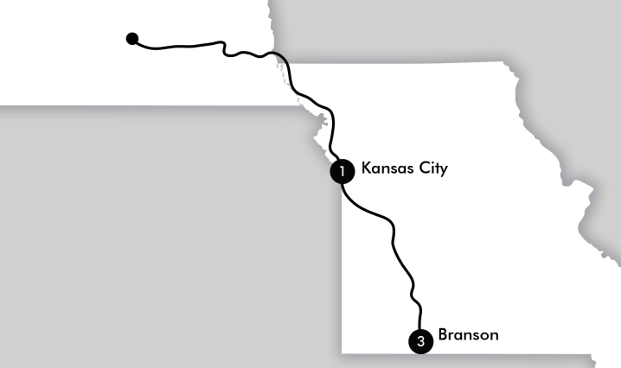
W H E R E T O ?
 | FINAL PAYMENT IS DUE: SEPTEMBER 5, 2024

