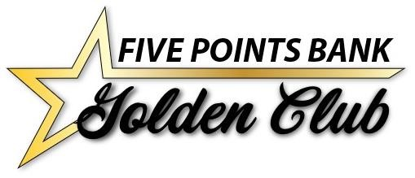
Mystery Casino Trip
October 20-22, 2020
Price: $290 Double, $390 Single
($15 discount for Omaha/Lincoln customers driving to GI for pickup)
“Some” meals, “some” free slot play, “some” entertainment, more than “some” fun. “Light” breakfast the morning of departure, 2 nights lodging, bus transportation, door prizes and great escorts to guide you along the way. If you have gone with us before you know this is a fun trip and sells out fast. Who knows where we are going?
We do know you will be glad you went!
Includes:
-Escorted Motor Coach with departures from Kearney and Grand Island

-2 nights Lodging
-$50 free play
-2 breakfasts, 1 Dinner
-$10 Food coupons for 2 days
Call Linda Green at 308-389-8783 or
Tracey at 308-698-2024
if you have any questions.

GOLDEN CLUB RESERVATION FORM
Mystery Casino Trip
October 20-22, 2020
$290.00

PASSENGER INFORMATION
First Name:___________________________________
Last Name:___________________________________
Name Tag:____________________________________
Address:______________________________________
City:_____________________ St:_______ Zip:______
Cell Phone:___________________________________
Email:_________________________________________
Date of Birth:_________________________________
Emergency Contact:_________________________
Emergency Contact Phone:_________________
PASSENGER INFORMATION
First Name:___________________________________
Last Name:___________________________________
Name Tag:____________________________________
Address:______________________________________
City:_____________________ St:_______ Zip:______
Cell Phone:___________________________________
Email:_________________________________________
Date of Birth:_________________________________
Emergency Contact:_________________________
Emergency Contact Phone:_________________
Special requests _____________________________ Special requests _____________________________
________________________________________________ ________________________________________________
One Bed _________ Two Beds _______________ Pick up location: _____________________________

Full payment is required with your reservation form.

Registration forms and checks may be made out and mailed to:
Five Points Bank Att: Linda Green
PO Box 1507, Grand Island NE 68803
OR
Debit my account #_____________________________________
Cancellation: NO charge if replacement is available (Name change)
Date registration taken ___________________

