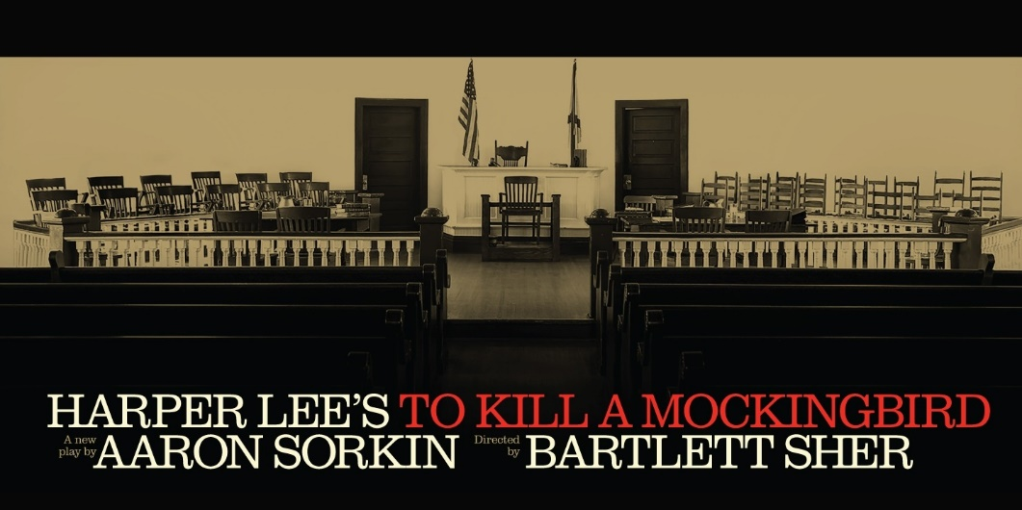
Harper Lee's American classic comes to Broadway in a new adaptation by Aaron Sorkin, directed by Bartlett Sher. Inspired by Lee’s own childhood in Alabama, the play features one of literature’s towering symbols of integrity and righteousness in the character of Atticus Finch, based on Lee’s own father. The character of Scout, based on Lee herself, has come to define youthful innocence – and its inevitable loss – for generation after generation of readers around the world.
WEDNESDAY June 12, 2024
7:30 P.M. SHOWTIME
ORCHESTRA LEVEL TICKETS
LIED CENTER – LINCOLN NE
$150.00
DINNER BEFORE THE SHOW
ROUND TRIP MOTOR COACH STARTING IN KEARNEY WITH PICK UPS AT SAMS CLUB AND 180/281

FOR RESERVATIONS OR MORE INFORMATION PLEASE CALL:
Linda Green at 308-389-8783, linda.green@5pointsbank.com
Tracey Shada at: 308-234-6171 tracey.shada@5pointbank.com

