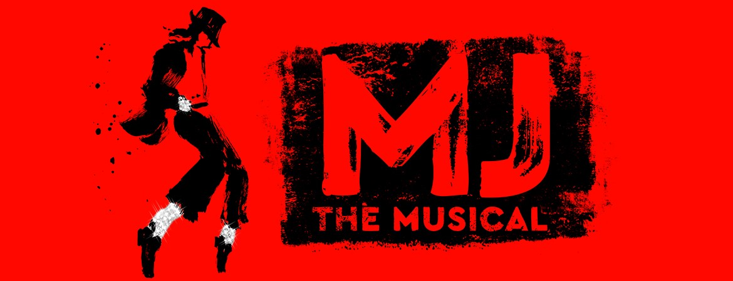

Friday, June 13, 2025 7:30 p.m.
Orpheum Theater Omaha, NE
MJ the Musical is a jukebox musical that explores the life of Michael Jackson, focusing on his creative process before his 1992 Dangerous World Tour. The musical features Jackson's music, and was created by Tony Award-winning director and choreographer Christopher Wheeldon and two-time Pulitzer Prize winner Lynn Nottage. t was nominated for 10 Tony Awards including Best Musical, with the musical winning four awards, including Best Actor in a Musical, as well as Best Choreography, Best Lighting Design and Best Sound Design. The original cast recording was also nominated for the Grammy Award for Best Musical Theater Album.
NEW FOR THIS SHOW: Tickets available for our Omaha customers.
Cost includes, Dinner before the show and show ticket. $160.00 for Omaha Customers
Cost $200.00
Tour includes:
-Deluxe motor coach transportation from Kearney with
pickups in Grand Island, I80/281 exit and Lincoln
-Dinner before the show
-Lower-level ticket for the show
Full payment is due with reservation. Cancellation Policy: If we have a waitlist, full refund is available
For reservations or more information, please call:
Linda Green at: 308-389-8783 linda.green@5pointsbank.com
or Tracey at: 308-234-6171 tracey.shada@5pointsbank.com

