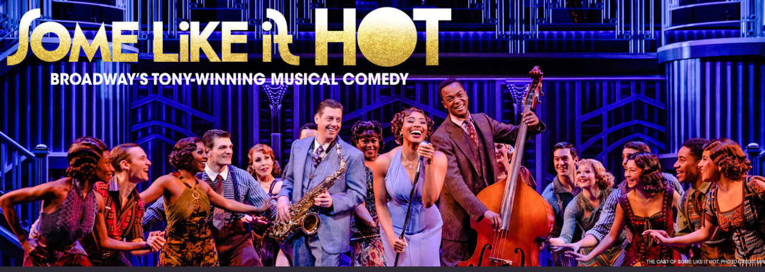
Thursday March 27, 2025 7:30 p.m.
Orpheum Theater Omaha, NE
The musical earned 13 2023 Tony award nominations. SOME LIKE IT HOT follows two Prohibition-era jazz musicians in Chicago (played on screen by Tony Curtis and Jack Lemmon), who witness a mob hit and go into hiding by disguising themselves as members of an all-female band. Through their escape plot, the two become enamored with the band's singer and ukulele player, Sugar, played on screen by Marilyn Monroe.

NEW FOR THIS SHOW: Limited number of tickets available for our Omaha customers.
Cost includes, Dinner before the show and show ticket. $125.00 for Omaha Customers

Cost $180.00
Tour includes:
-Deluxe motor coach transportation from Kearney with
pickups in Grand Island, I80/281 exit and Lincoln
-Dinner before the show
-Lower-level ticket for the show
Full payment is due with reservation. Cancellation Policy: If we have a waitlist, full refund is available
For reservations or more information, please call:
Linda Green at: 308-389-8783 linda.green@5pointsbank.com
or Tracey at: 308-234-6171 tracey.shada@5pointsbank.com

